Here are five writing prompts for you to get YOU inspired. Try all of them if you want, or just one.

1—Freewrite for eight minutes to add more to these words here:
In seven years time, I will be….

2—In this image, Polly Diamond is thinking about writing in her book. Everything she writes in her magic book comes true. What would you write in a magic book?
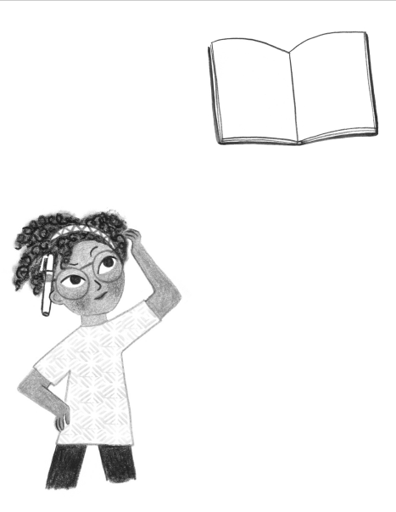

3—Write down one word after each of these words. Whatever comes into your head:

POP

LAKE

BANANA

RUN

VACATION

Use one of these word pairs to write a story.

4—In this image from Ben Clayton’s amazing Narwhal and Jelly books, the jellyfish has an idea: the waffle should have a sidekick. A strawberry. Write a story or a poem about a waffle and a strawberry.
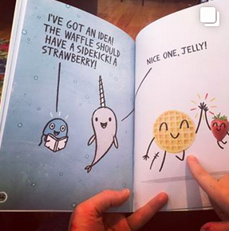
5—Draw a picture of what an idea looks like. If an idea is an animal. It could be a made-up animal or a cat—whatever you want the idea to be. Write about the idea-animal afterwards….

(If you want to do more writing prompts, come and join my free writing course for kids: https://writingblueprints.com/p/writing-course-ages-6-10/ )

